GYGA Methodology wheat in Egypt

Wheat Production in Egypt
Egypt has a very arid climate, and agricultural production mostly relies on irrigation1,2). The area of agricultural land in Egypt is mainly confined to the Nile Valley and delta. Arable land (% of land area) is around 3 % (4.5 %) 3). The total population in Egypt was estimated at 96.2 million people in 2017, and employment in agriculture (% of total employment) is 25% in 2017. Wheat, maize, and rice are the major cereals (50% of maize is used for animal feeding). Their productivity is high (see below Table)4), since they are grown under irrigated, intensive systems5, 6). However, today, water scarcity is a major concern in this country and it dictates policy measures including reduction in rice area.

- http://www.fao.org/docrep/v9978e/v9978e0e.htm
- http://www.fao.org/docrep/005/Y4632E/y4632e0c.htm
- https://tradingeconomics.com/egypt/arable-land-hectares-wb-data.html
- http://www.fao.org/faostat/en/
- Saito, K., Dieng, I., Toure, A., Somado, E.A., Wopereis, M.C.S. 2015. Rice yield growth analysis for 24 African countries over 1960–2012. Global Food Security 5, 62-69.
- van Oort, P.A.J., Saito, K., Tanaka, A., Amovin-Assagba, E., Van Bussel L.G.J., van Wart, J., de Groote, H., van Ittersum, M.K., Cassman, K.G., Wopereis, M.C.S. 2015. Assessment of rice self-sufficiency in eight African countries in 2025. Global Food Security 5, 39-49

Harvested Area

Harvested area of irrigated wheat was retrieved from SPAM2010 v1.1 (You et al, 2014).

Weather data and reference weather stations (RWS)

In total, 2 RWSs belonging to 2 different climate zones were selected following the GYGA protocols. The buffer zones of the designated RWSs cover 59% of the wheat national harvested area.
Weather data for … years (20..-20..), including maximum and minimum temperatures, sunshine hours, wind speed, relative humidity and precipitation were collected from ...
Weather data has been collected from local weather stations deployed in Sakha Agricultural Research Station, Kafr Elsheikh.
- 1st weather station: 31.098144, 30.943340
- 2nd weather station: 31.092340, 30.908627

Actual yields
Actual yields data from 2013 to 2019 was collected from …. .
- Sources: Wheat Research Dept., Field Crops Research Institute, Agriculture Research Center (ARC), Ministry of Agriculture and Land Reclamation.
- Extension advisory system, Ministry of Agriculture.

Please clarify these 1) growing season and periods from 2) emergence to anthesis and 3) anthesis to maturity for Upper Egypt.

Growth stages | Lower Egypt | Upper Egypt
Planting date | 10-30 Nov | 1-20 Nov
Germination | 5-9 days | 4-8 days
Anthesis | 25 Feb – 10 March | 15-25 Feb
Maturity | 15 April – 10 May | 25 March – 15 April

Model calibration

The Python implementation (PCSE) of the WOFOST crop growth model was used to estimated wheat potential yield under irrigated conditions. The model was calibrated using ...

References
You, L., U. Wood-Sichra, S. Fritz, Z. Guo, L. See, and J. Koo. 2014. Spatial Production Allocation Model (SPAM) 2010 V1r1. [October 8, 2019]. Available from http://mapspam.info and on IFPRI’s Dataverse Site.

Regarding the data outliers.
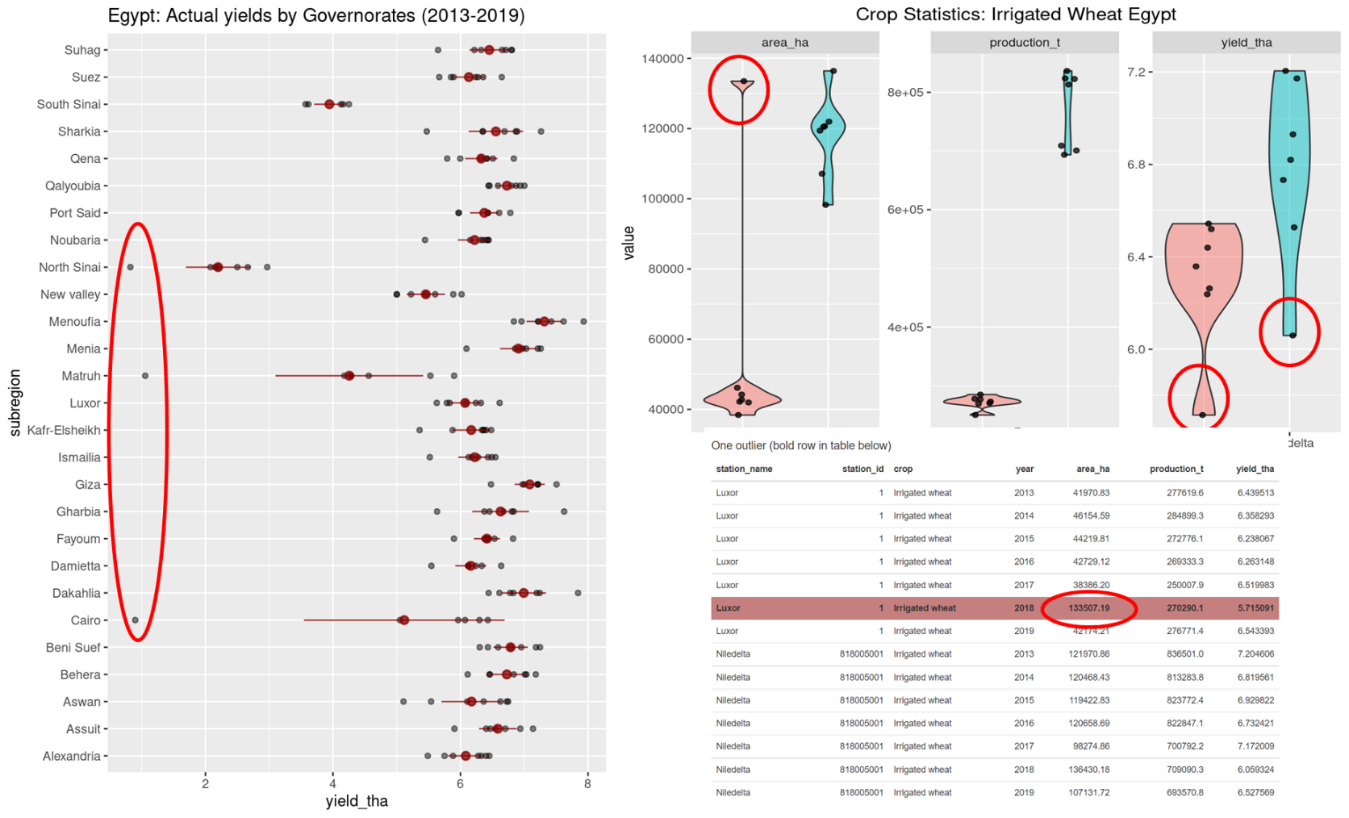

ARC colleague, looked at this, said not sure which year you are referring to the those out liars, can you mention the year in graph to check environmental conditions for those years?

In general, he said following points;
- There was a sever yellow rust in 2018/2019 season
- Outlier of know yield also related rainfed wheat, the Matruh and north Sinai governorates are of rainfed agriculture, thus rainfall is the most limiting factor in some years rain- low rainfall or heavy rainfall both leads to low yield. Heavy that it caused soil erosion and loss of soil nutrients leads wheat yield reduction.
- Regarding wheat area reduction in Luxor governorate as 133507.16 ha in one year, it was probably due to shift in sugar cane and wheat but this need to be checked with colleagues and get back to you.

